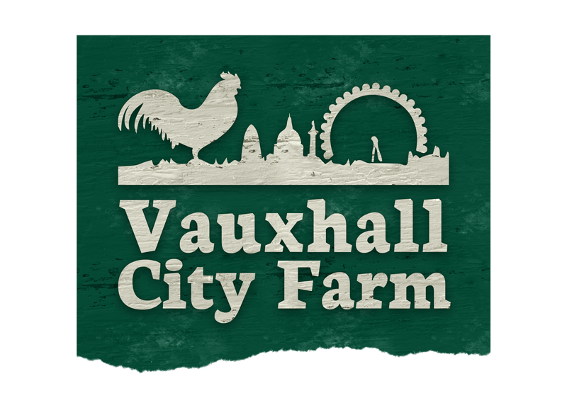

Riding Volunteer Application Form (over 16)

Before completing this form, please ensure you can say yes to the following

I am physically fit
I am able to work independently (without additional support)

If you are unable to answer yes to the above, please email us to find out if there are any supported programmes currently running at the farm.

If you can answer yes to the above, please complete and return the form to:

riding@vauxhallcityfarm.org | or post to:  Vauxhall City Farm  165 Tyers Street  SE11 5HS

Name
Mobile number

E mail

How many days a month can you commit to?

Which days & times of the week can you commit to?

Personal Details

Address

Borough
Date of Birth
Emergency contact name and phone number
Are you currently: | Employed | Unemployed | Full time Education or Training | Part time Education or Training

If you are unemployed, not in education or training, please give details below:

- Additional Information about you

Please tell us a little about yourself

Please tell us about your previous experience with horses
(e.g. mucking out, yard work, tacking up, schooling etc)

Please briefly outline any relevant training or qualifications

- Health & Safety

A lot of the roles at Vauxhall City Farm require a degree of physical fitness. Some activities (financial, administrative, and secretarial) do not. Please declare any limitations on your ability to participate in any activities to enable us to best support you.

Physical, sensory, learning disability or difficulty
Mental Health disability or difficulty

Any other medical conditions

(Epilepsy, Asthma, Diabetes, Allergies etc.)

If you have said yes to any of the above, please specify how this impacts on your day to day life

Tetanus Vaccination: | It is recommended that you have an up to date tetanus vaccination when working with animals, please sign here to confirm you have read and understand this advice:

Disclosure

Have you ever had any convictions, cautions, reprimands or final warnings which are not "protected" as defined by the Rehabilitation of Offenders Act 1974 (Exceptions) Order 1975 (Amendment) (England and Wales) Order 2013?

Yes/No (please delete as appropriate)

Please note we will discuss this with you at induction. Please be assured that a positive declaration will not necessarily prevent you from volunteering with us.

Declaration
I declare that the information provided on this form is correct.

Signed: ________________________________ Date: _______________________

